Assignment 1
Question: Determine the Structure of DEPT Table and its Contents.
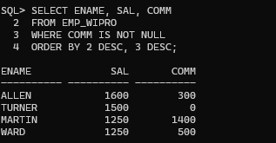

Assignment 2
Question:
The HR department needs a query to display all unique job codes from the EMP table.
Query:
SELECT DISTINCT JOB
FROM EMP_WIPRO;

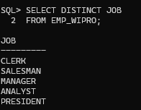

Assignment 3
Question:
The HR department wants more descriptive column headings for its report on employees. Name the column headings Emp #, Employee, Job, and Hire Date respectively by giving Column Alias.
Query:
SELECT EMPNO AS "Emp #",
ENAME AS "Employee",
JOB AS "Job",
HIREDATE AS "Hire Date"
FROM EMP_WIPRO;

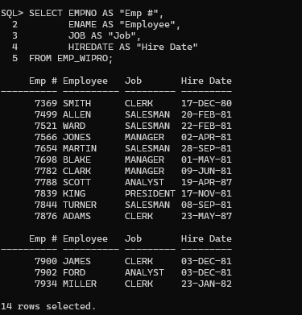

Assignment 4
Question:
The HR department has requested a report of all employees and their job IDs. Display the employee name concatenated with the job ID (separated by a comma and space) and name the column Employee and Title by giving Column Alias.
Query:
SELECT ENAME || ', ' || JOB AS "Employee and Title"
FROM EMP_WIPRO;

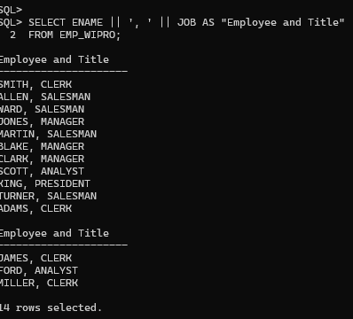

Assignment 5
Question:
To familiarize yourself with the data in the EMP table, create a query to display ENAME, JOB, HIREDATE, and MGR separated by commas. Name the column title THE_OUTPUT.
Query:
SELECT ENAME || ',' ||
JOB || ',' ||
HIREDATE || ',' ||
MGR AS THE_OUTPUT
FROM EMP_WIPRO;

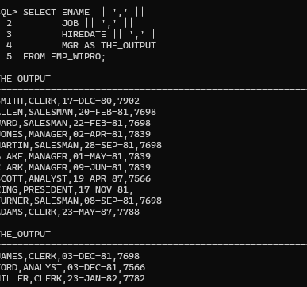

Assignment 6
Question:
Create a report to display the ENAME, JOB, and HIREDATE for the employees whose name is SCOTT or TURNER. Order the query in ascending order by Hire Date.
Query:
SELECT ENAME, JOB, HIREDATE
FROM EMP_WIPRO
WHERE ENAME IN ('SCOTT','TURNER')
ORDER BY HIREDATE ASC;
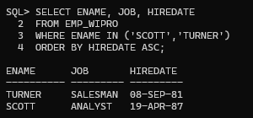
Assignment 7
Question:
Display the ENAME and DEPTNO of all employees in departments 20 or 30 in ascending alphabetical order by ENAME.
Query:
SELECT ENAME, DEPTNO
FROM EMP_WIPRO
WHERE DEPTNO IN (20,30)
ORDER BY ENAME;
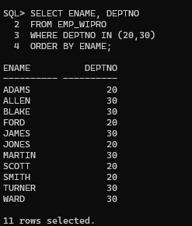

Assignment 8
Question:
Modify the previous query to display the ENAME and SAL of employees who earn between 2000 and 3000 and are in department 20 or 30. Label the columns Employee and Monthly Salary respectively by giving Column Alias.
Query:
SELECT ENAME AS "Employee",
SAL AS "Monthly Salary"
FROM EMP_WIPRO
WHERE SAL BETWEEN 2000 AND 3000
AND DEPTNO IN (20,30);
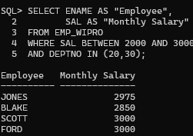
Assignment 9
Question:
The HR department needs a report that displays the last name and hire date for all employees who were hired in 1981.
Query:
SELECT ENAME, HIREDATE
FROM EMP_WIPRO
WHERE EXTRACT(YEAR FROM HIREDATE) = 1981;
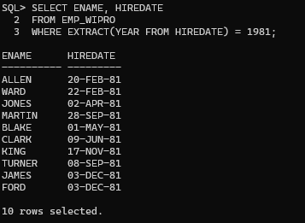
Assignment 10
Question:
Display the ENAME and SAL of employees who earn more than an amount the user specifies after a prompt.
Query:
ACCEPT AMT NUMBER PROMPT 'Enter Salary: '

SELECT ENAME, SAL
FROM EMP_WIPRO
WHERE SAL > &AMT;
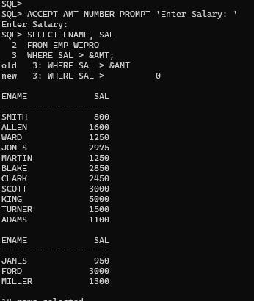
Assignment 11
Question:
Create a report to display the last name and job title of all employees who do not have a manager.
Query:
SELECT ENAME, JOB
FROM EMP_WIPRO
WHERE MGR IS NULL;
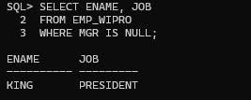

Assignment 12
Question:
Create a query that prompts the user for Manager ID and generates EMPNO, ENAME, SAL, DEPTNO. The user should have the ability to sort the records on a selected column.
Query:
ACCEPT MID NUMBER PROMPT 'Enter Manager ID: '
ACCEPT COL CHAR PROMPT 'Enter Column Name: '

SELECT EMPNO, ENAME, SAL, DEPTNO
FROM EMP_WIPRO
WHERE MGR = &MID
ORDER BY &COL;
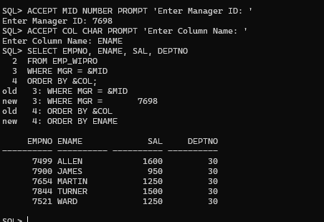

Assignment 13
Question:
The HR department wants to run reports based on a manager. Create a query that prompts the user for a MGR and generates the EMPNO, ENAME, SALARY, and DEPARTMENT for that manager's employees. The HR department wants the ability to sort the report on a selected column.
Query:
ACCEPT MID NUMBER PROMPT 'Enter Manager ID: '
ACCEPT COL CHAR PROMPT 'Enter Column Name: '

SELECT EMPNO,
ENAME,
SAL,
DEPTNO
FROM EMP_WIPRO
WHERE MGR = &MID
ORDER BY &COL;

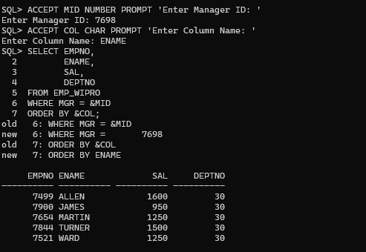

Assignment 14
Question:
Display all employee last names in which the third letter of the name is A.
Query:
SELECT ENAME
FROM EMP_WIPRO
WHERE ENAME LIKE '__A%';
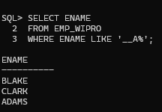
Assignment 15
Question:
Display the last name of all employees who have both an A and an S in their ENAME.
Query:
SELECT ENAME
FROM EMP_WIPRO
WHERE ENAME LIKE '%A%'
AND ENAME LIKE '%S%';

